Bounded Buffer Problem:
#include<stdio.h>
#include<stdlib.h>

#define MAX 3
int empty = MAX;
int mutex = 1, full = 0, x = 0, y = 1;

int main()
{
int n;
void producer();
void consumer();
int wait(int);
int signal(int);
printf("1.Producer\n2.Consumer\n3.Exit");
while(1)
{
printf("\nEnter your choice: ");
scanf("%d",&n);
switch(n)
{
case 1: if((mutex==1)&&(empty!=0))
producer();
else
printf("Buffer is full!\n");
break;
case 2: if((mutex==1)&&(full!=0))
consumer();
else
printf("Buffer is empty!\n");
break;
case 3:
exit(0);
break;
}
}

return 0;
}

int wait(int s)
{
return (--s);
}

int signal(int s)
{
return(++s);
}

void producer()
{
mutex=wait(mutex);
full=signal(full);
empty=wait(empty);
x++;
if(y > 1)
y--;
printf("Producer produces the item %d\n",x);
mutex=signal(mutex);
}

void consumer()
{
mutex=wait(mutex);
full=wait(full);
empty=signal(empty);
printf("Consumer consumes item %d\n",y);
x--;
y++;
if(y > MAX)
y = 1;
mutex=signal(mutex);
}
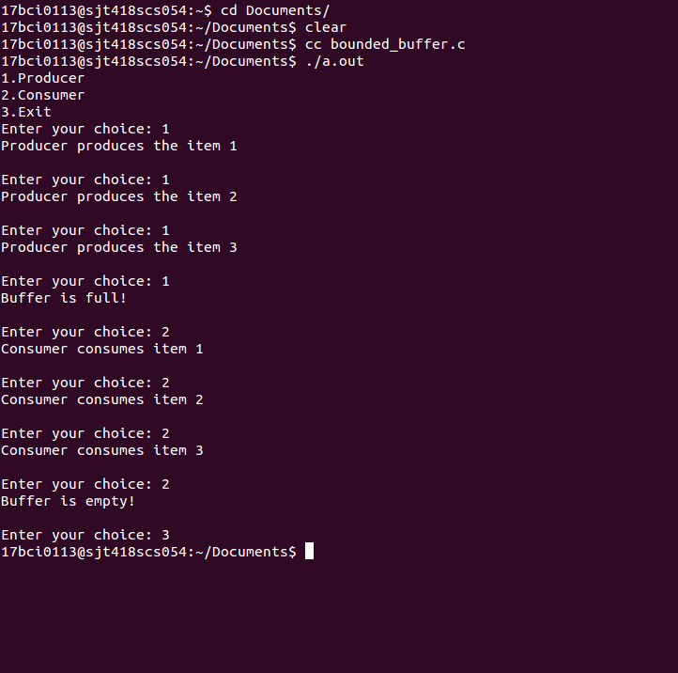
Dining Philosophers Problem:
#include <pthread.h>
#include <semaphore.h>
#include <stdio.h>

#define N 5
#define THINKING 2
#define HUNGRY 1
#define EATING 0
#define LEFT (phnum + 4) % N
#define RIGHT (phnum + 1) % N

int state[N];
int phil[N] = { 0, 1, 2, 3, 4 };

sem_t mutex;
sem_t S[N];

void test(int phnum)
{
if (state[phnum] == HUNGRY
&& state[LEFT] != EATING
&& state[RIGHT] != EATING)
{
state[phnum] = EATING;

sleep(2);

printf("Philosopher %d takes fork %d and %d\n",
phnum + 1, LEFT + 1, phnum + 1);

printf("Philosopher %d is Eating\n", phnum + 1);

sem_post(&S[phnum]);
}
}

void take_fork(int phnum)
{

sem_wait(&mutex);

state[phnum] = HUNGRY;

printf("Philosopher %d is Hungry\n", phnum + 1);

test(phnum);

sem_post(&mutex);

sem_wait(&S[phnum]);

sleep(1);
}

void put_fork(int phnum)
{

sem_wait(&mutex);

state[phnum] = THINKING;

printf("Philosopher %d putting fork %d and %d down\n",
phnum + 1, LEFT + 1, phnum + 1);
printf("Philosopher %d is thinking\n", phnum + 1);

test(LEFT);
test(RIGHT);

sem_post(&mutex);
}

void* philospher(void* num)
{

while (1) {

int* i = num;

sleep(1);

take_fork(*i);

sleep(0);

put_fork(*i);
}
}

int main()
{

int i;
pthread_t thread_id[N];

// initialize the semaphores
sem_init(&mutex, 0, 1);

for (i = 0; i < N; i++)

sem_init(&S[i], 0, 0);

for (i = 0; i < N; i++) {

// create philosopher processes
pthread_create(&thread_id[i], NULL,
philospher, &phil[i]);

printf("Philosopher %d is thinking\n", i + 1);
}

for (i = 0; i < N; i++)

pthread_join(thread_id[i], NULL);
}
